**Download Oomph Eclipse installer for your platform from**[**https://wiki.eclipse.org/Eclipse_Installer**](https://wiki.eclipse.org/Eclipse_Installer)

**Run it…**

**Change to “ADVANCED MODE”**

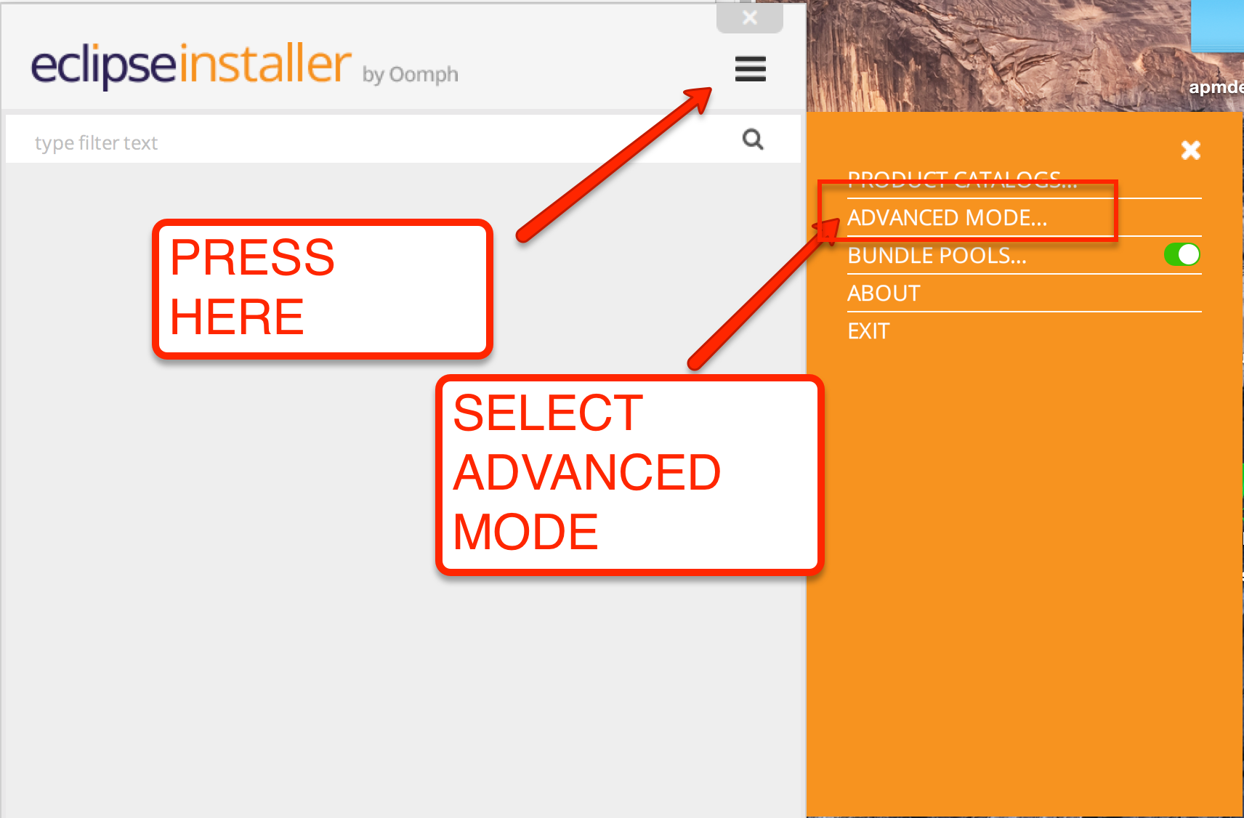

**Press the Green “plus” + icon**

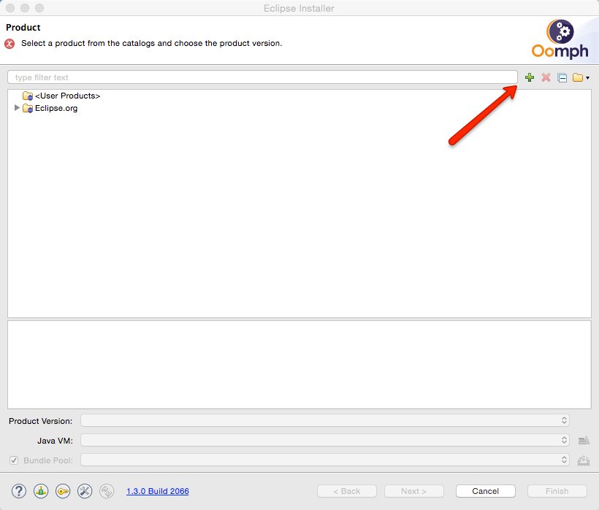

**Then paste the below URL into the dialog…**

<https://raw.githubusercontent.com/DuaneNielsen/APMFieldDeveloperSetup/master/APMFieldDeveloper.setup>

ƒa

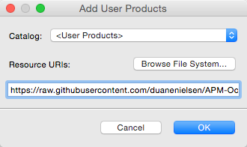

**Then select APMFieldDeveloper and press next**

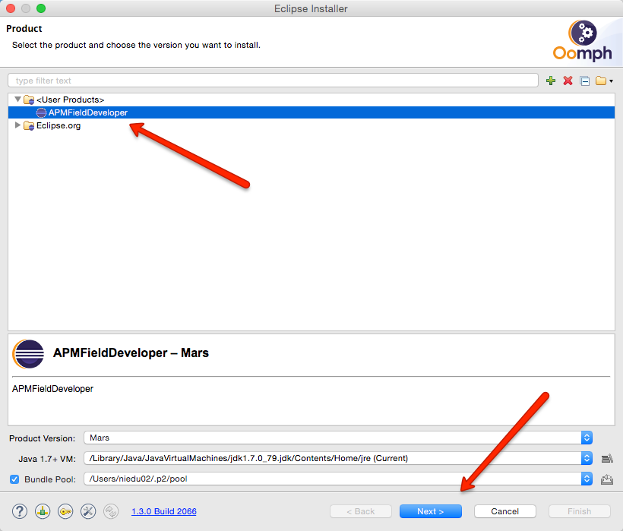

**Ignore the next screen and press next**

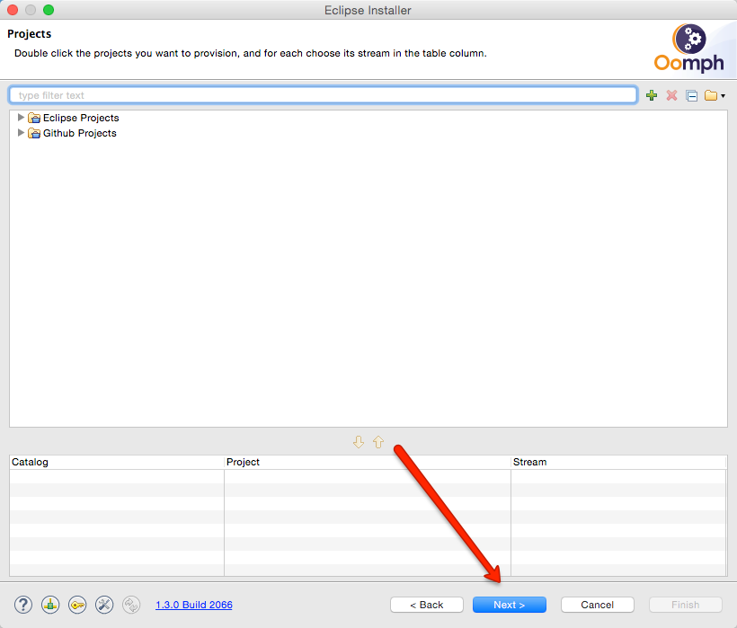

**Select where you want it to install the eclipse application, or accept the default, and press next**

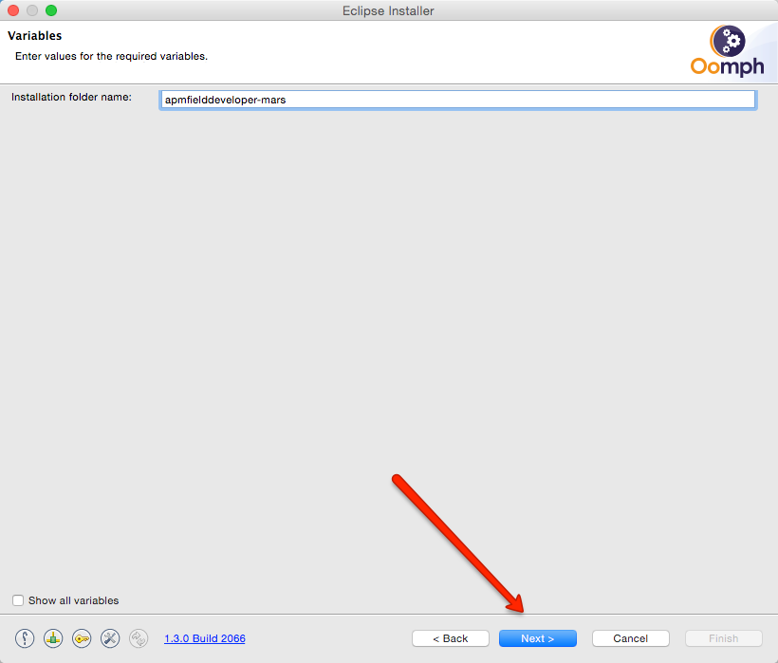

**Press finish**

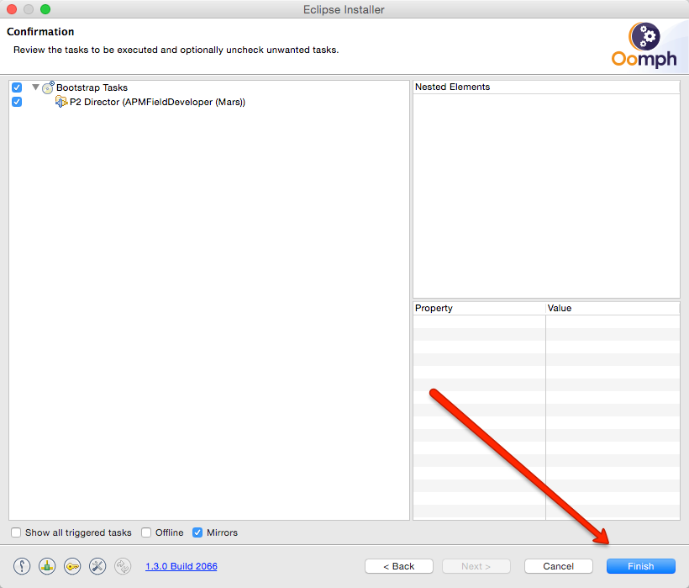

**It will install eclipse, with maven, check-style, and git.  You will need to accept licenses and unsigned content.**

**Then it will launch eclipse, and ask for a workspace… give it a new one**

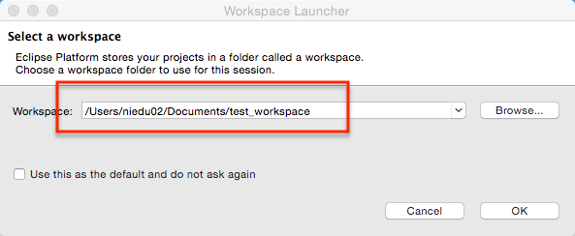

**That’s it. You are done…  New workspace with all the correct settings should be open and ready to go.**

**If you are connected to CA VPN, You can get the Maven Archetypes now……**

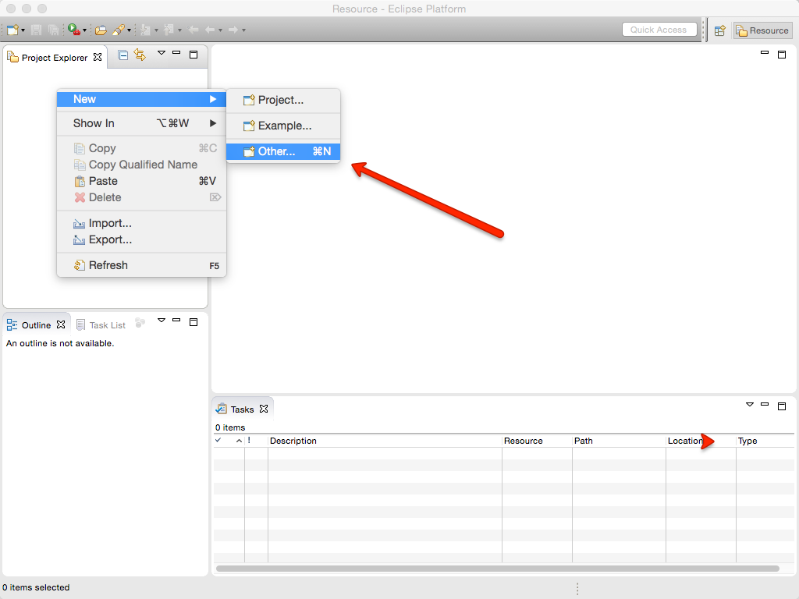

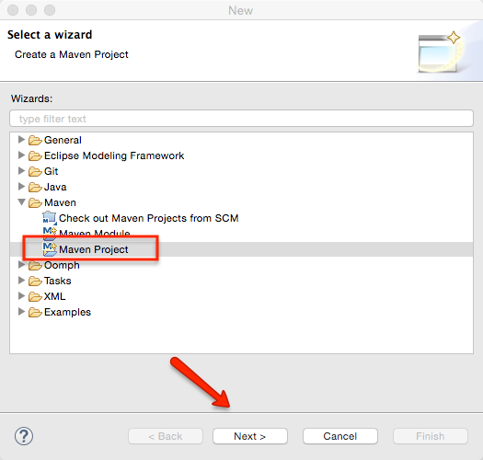

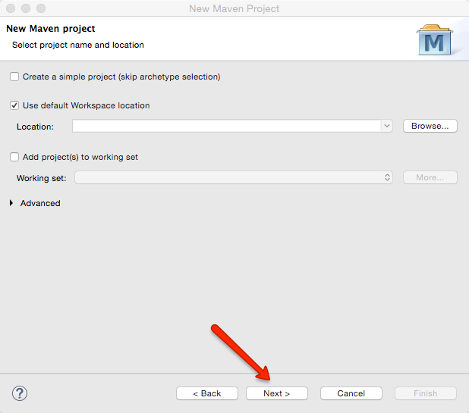

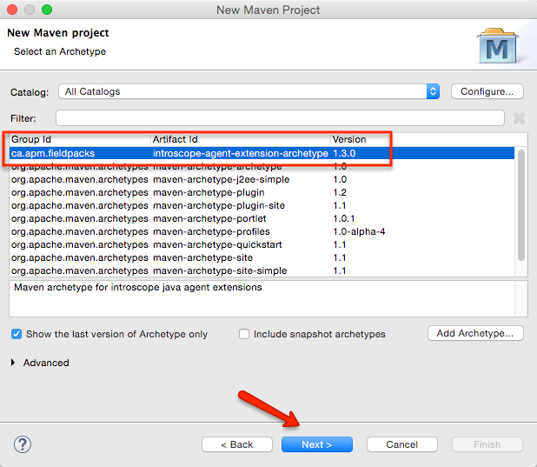

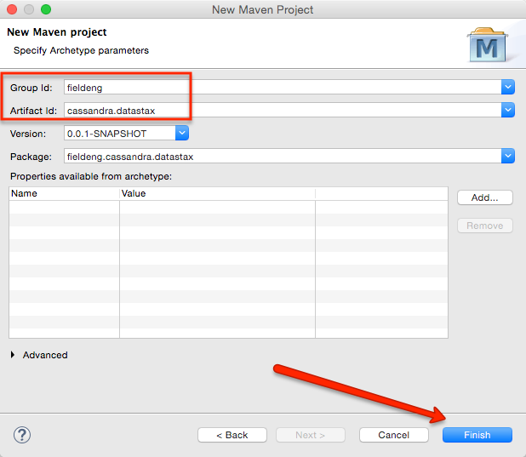

**And BOOM!  I think it should take less that 5 minutes to get a build-able template…**

